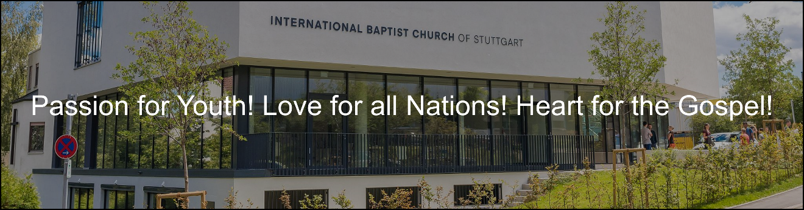

Application Form
Ministerial Staff Position
International Baptist Church of Stuttgart
Untere Waldplaetze 38
70569 Stuttgart
Germany

This file is sent in a .doc format. Please answer the questions and return it to office@ibcstuttgart.de

Personal Information:

Your Full Name:

Your Date of Birth:

Your Mailing Address:

Your Email Address:

Your Telephone Number:

Your Interest in IBC Stuttgart

Why are you interested in serving in an international church in Germany?

What are some of the concerns you have about living in Germany?

What are your expectations from IBC Stuttgart?

Your Education:

Where did you complete High School?

Where did you complete university studies? Major? Minor?

Do you have graduate level work? Where? What subjects?

Your Ministerial Experience:

Where have you served so far in your personal ministry? What positions? What were the responsibilities of these positions? What has been some of the fruit of your ministry in these positions?

How have these prepared you to minister to the youth and students at International Baptist Church of Stuttgart?

Please briefly describe your philosophy and understanding of youth ministry. Where possible please provide examples from your experiences.

How do you think your youth ministry philosophy would apply in an international setting?

How would you describe the following:

- Your teaching style
- Your leadership style
- Your area of gifting and passion
- Your approach to equipping others
- Your approach to discipleship of youth
- What topics are important to teach youth?

Your Long Term Goals:

What do you see yourself doing in ten years?

What are your personal and educational goals?

What passions has God placed on your heart?

What do you believe to be your spiritual gifts?

Our church is committed to the growth and development of its staff. Are you personally open to receive regular evaluations of ministry performance and encouragements toward growth and further development?

Church Experience and Doctrinal Position

Please share your conversion experience: When were you saved?

How would you describe your theological position?

Please share with us your experience of calling into ministry:

Please read our Statement of Faith online. Are there areas that are unclear to you where the church stands? Are there areas where you are not in agreement? Please state these plainly.

Are you able to work within the doctrinal framework of the International Baptist Church of Stuttgart?

Where do you stand on the inspiration and authority of Scriptures?

What are your views on the speaking of tongues and prophecy?

Where do you stand on the issue of Eternal Security of Salvation and Assurance of Salvation?

Do you have any certificates for ministry: Ordination? Special seminars or other qualifications?

